Project Name: Life-Generator  
Name: Danny Sulsberger

Formal Use Case w/revisions:

Name: Generate List of highest rated toys by Client input  
Actor: Client – Sales team member  
Identifier: LG-001  
Flow:

1. Client opens Desktop app from their work computer
2. Client chooses ‘toy’ from a list of items
3. Client chooses a ‘category’ from a list of categories
4. Client specifies number of toys to output by typing
5. Client presses ‘generate’ button
6. Software opens CSV containing Sales Information from Kaggle
7. Software takes input and sorts/filters data
8. Software generates results
9. Software displays output on GUI

Suggstion from Tingtin Fang in discussion

Tingtin’s suggestion adds some more visibility to the use case as to the source and what the software is actually doing with the input and source data. It’s just a bit more visibility without diving into the complexities of how the program functions – I think it was a great suggestion, more visibility never hurts.

Name: Generate List of highest rated toys using CSV  
Actor: Client – Sales team member  
Identifier: LG-002  
Flow:

1. Client opens Desktop app from their work computer
2. Client uploads CSV where headers contain correct info per software docu
3. Client presses ‘generate’ button
4. Software generates results
5. Software creates output.csv
6. Prints to console that output.csv was successfully created

Suggestion from Connor Murnion in discussion

I’m actually adding Connor’s suggestion into the functionality of my program now as it’s   
 going to help users confirm that the query/software worked and what the output file is   
 named. It’s a great suggestion, and one that I probably wouldn’t have thought of since I   
 wrote the software and know it outputs x to directory y.

UML Sequence diagram w/revisions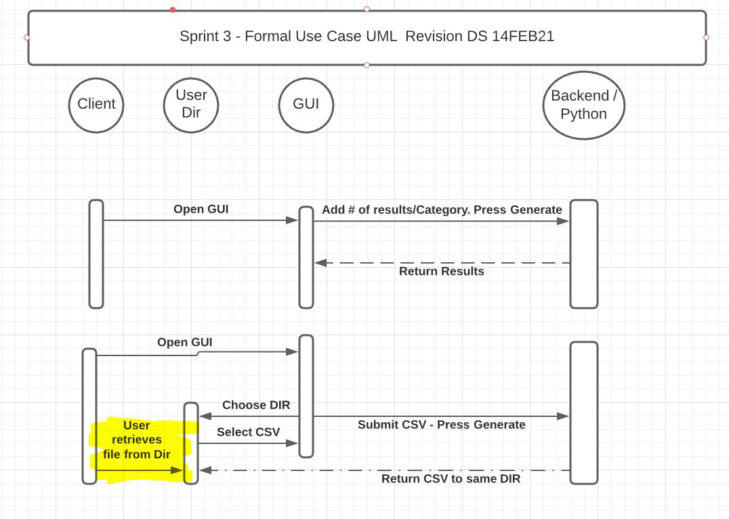

I added an arrow indicating that the client must retrieve the CSV from the user directory (in yellow) as the program won’t direct them or automatically open up that directory. I think it adds clarity to the UML so it’s clear that the client will have to retrieve the file on their own.

I also split my two Formal Use cases up (in the discussion submission they were all one) per a suggestion in the discussion. While both use cases were together, it appeared that the client had to do both GUI then the automatic cases – which is not the case.

Task Management System: Jira  
Updated all tasks to Done

Original From Discussion:

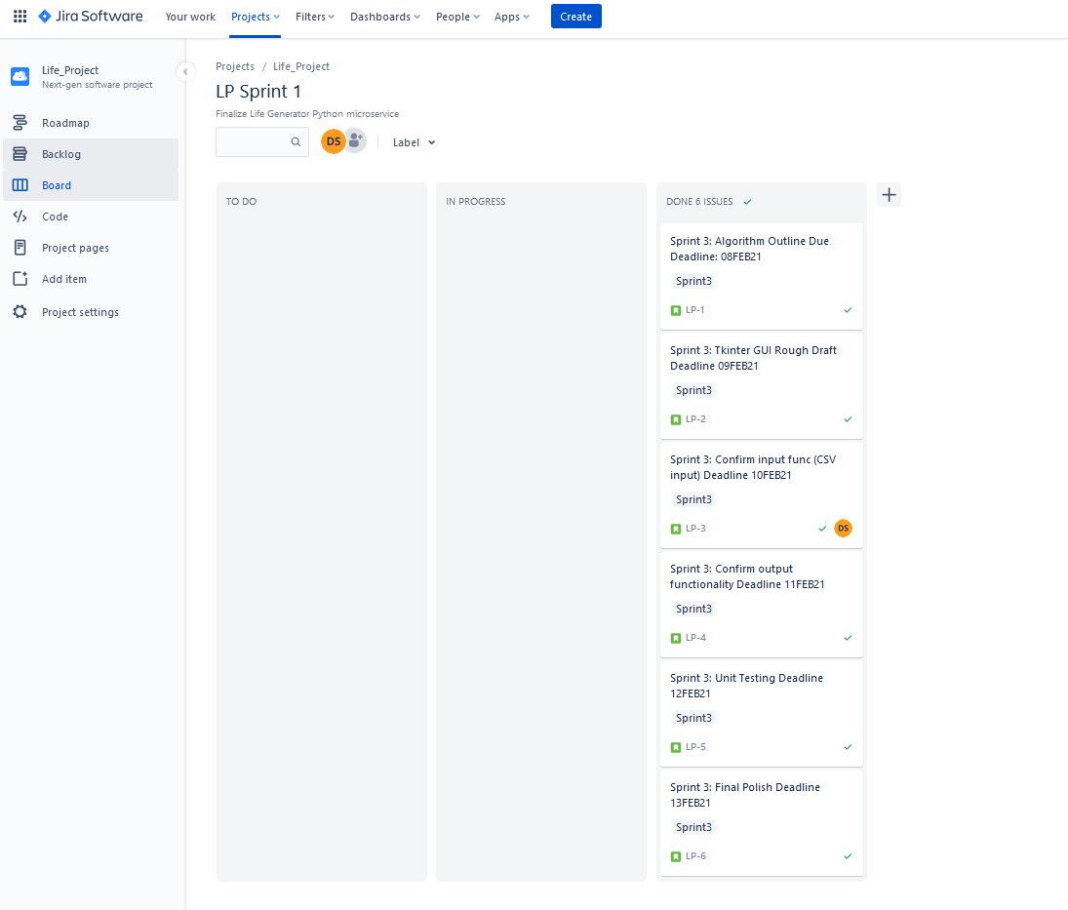

Tasks 1/2

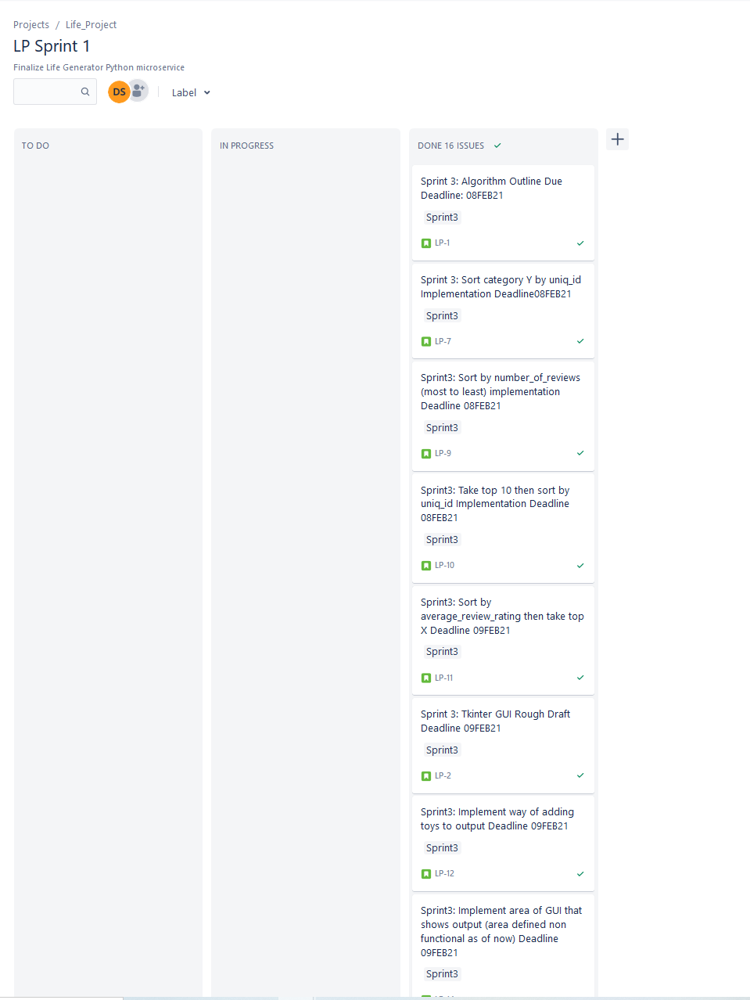

Tasks 2/2

